HOS09A - SQL Database II
Nilson Sousa | CS 11A Technology & Computing Components I

Section 1: Use Azure SQL Database and learn SQL Queries
Connected to the AdventureWorks database in Azure SQL and ran each query below in the Query editor.

1a. Simple SELECT Statement using JOINS
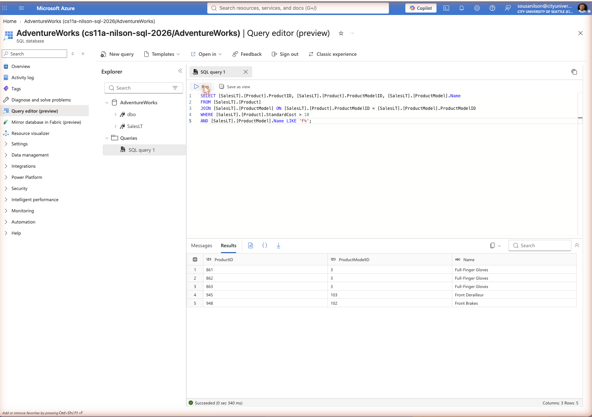

Technical: What is the command for? Why would you use the command?
This query uses an INNER JOIN to combine the Product and ProductModel tables on ProductModelID, filtered to products with a StandardCost greater than $10 whose model name starts with "F". A JOIN is used because ProductID/ProductModelID data lives in one table while the readable model Name lives in another, normalized table; the JOIN lets the query pull both pieces of information into a single result set.
Application: What type of business user needs this information? Why does it need this information?
A purchasing or inventory manager would use this to identify higher-cost products within a specific product family (model names starting with "F", such as Front Derailleur, Front Brakes, and Full-Finger Gloves) for cost review or supplier negotiation.

1b. SELECT Statement using JOINS with improved readability
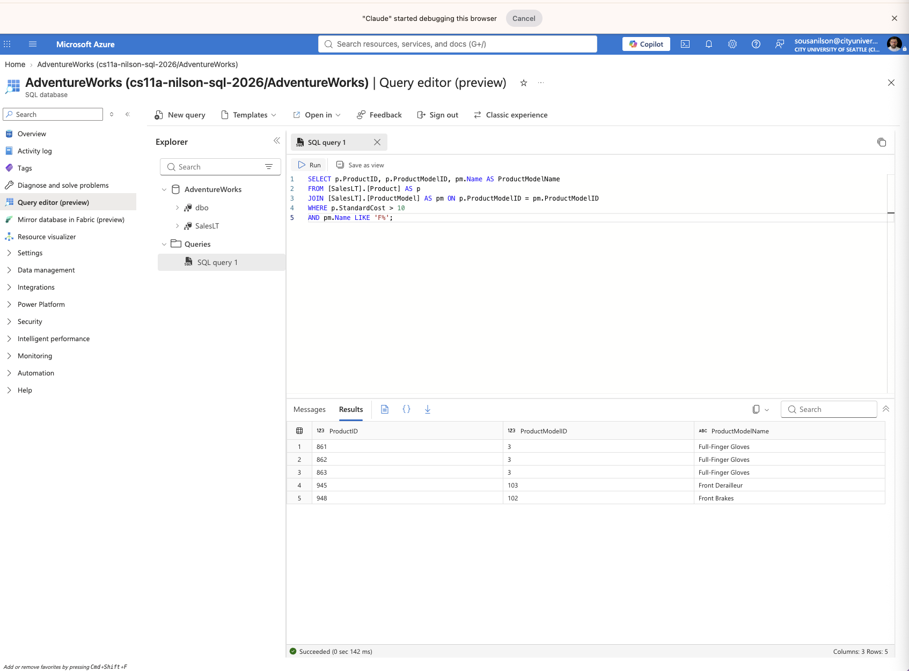

Technical: What is the command for? Why would you use the command?
This is the same JOIN as 1a, rewritten using table aliases (p for Product, pm for ProductModel) instead of fully qualified table names. Aliases shorten the query and make it easier to read and maintain, especially as more tables or conditions are added.
Application: What type of business user needs this information? Why does it need this information?
Same business need as 1a. A report developer building queries for a purchasing or inventory manager would prefer this style since it is faster to write and easier to maintain over time.

2. Subqueries (subquery as a column expression)
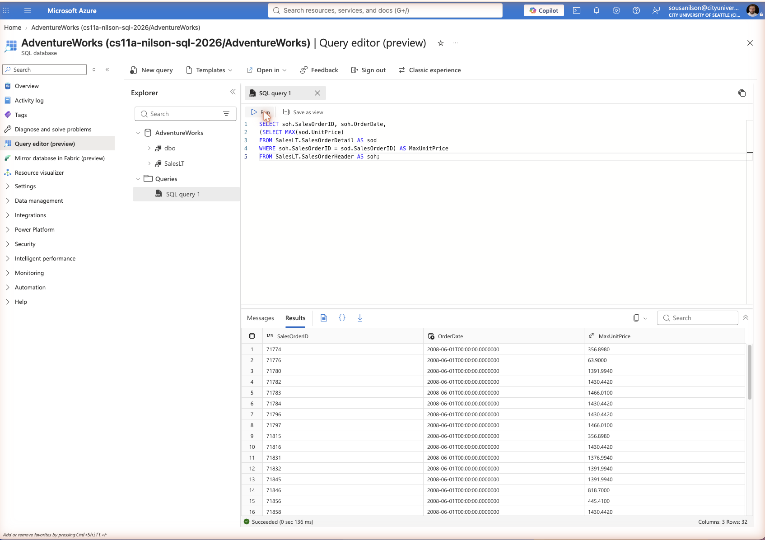

Technical: What is the command for? Why would you use the command?
A subquery is nested inside the SELECT list to calculate the maximum unit price for each sales order, evaluated independently for every row of the outer query. This is used when a summary value from a related child table needs to appear alongside each row of the main table without a separate GROUP BY query.
Application: What type of business user needs this information? Why does it need this information?
A sales manager could use this to see, order by order, the single highest-priced line item in each sale, which is useful for auditing large orders or spotting premium purchases.

2a. Subquery SELECT and a join SELECT (Part I)
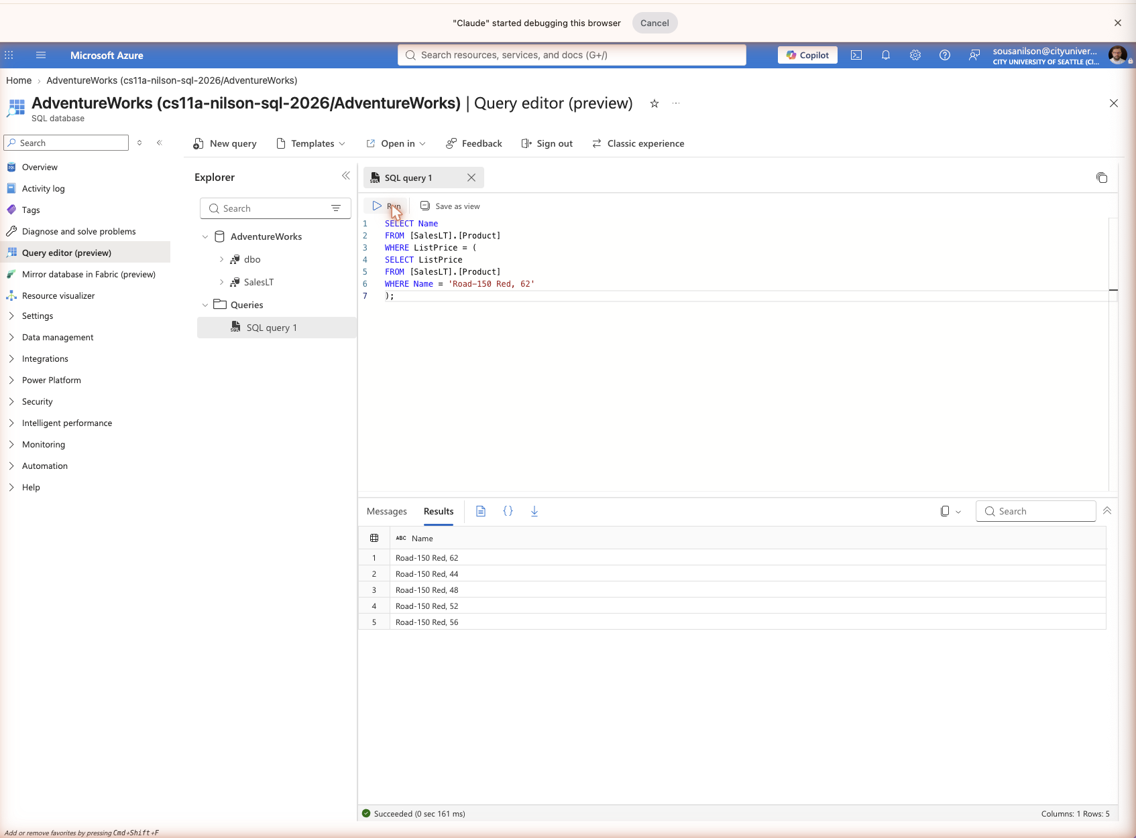

Technical: What is the command for? Why would you use the command?
The inner subquery first looks up the ListPrice of one named product, and the outer query then returns the names of every product sharing that exact list price. This lets you find "peer" products at the same price point without hardcoding the price value itself.
Application: What type of business user needs this information? Why does it need this information?
A product manager comparing pricing tiers could use this to see which other products (here, different frame sizes of the same Road-150 model) are priced identically, which is useful for catalog pricing consistency checks.

2b. Subquery SELECT and a join SELECT (Part II)
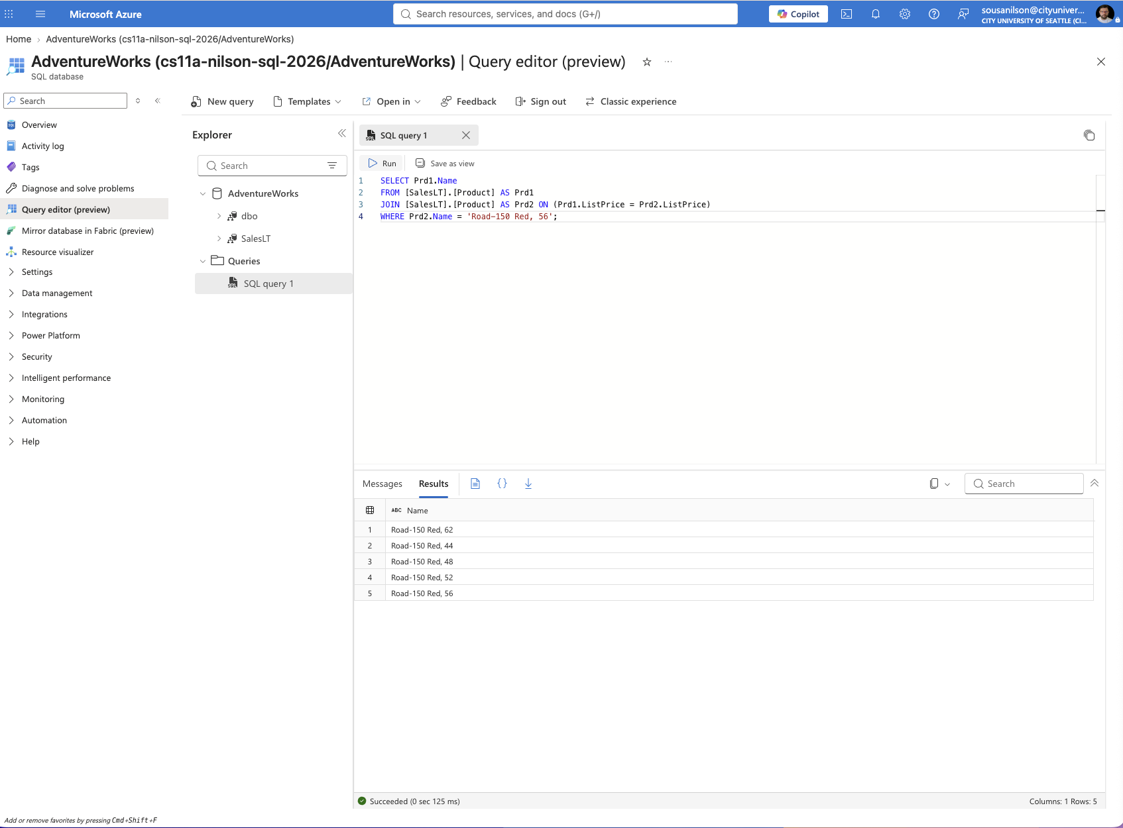

Technical: What is the command for? Why would you use the command?
This rewrites the exact same logic as Part I using a self join instead of a nested subquery: the Product table is joined to itself on matching ListPrice, filtered to rows where the second copy of the table matches the target product name. Both approaches return the identical result set.
Application: What type of business user needs this information? Why does it need this information?
Same business need as Part I. This version is useful to show a report developer that the same business question ("what else is priced the same as product X") can be answered with either a subquery or a join, letting them pick whichever reads or performs better in their environment.

2c. Qualifying column names in Subqueries
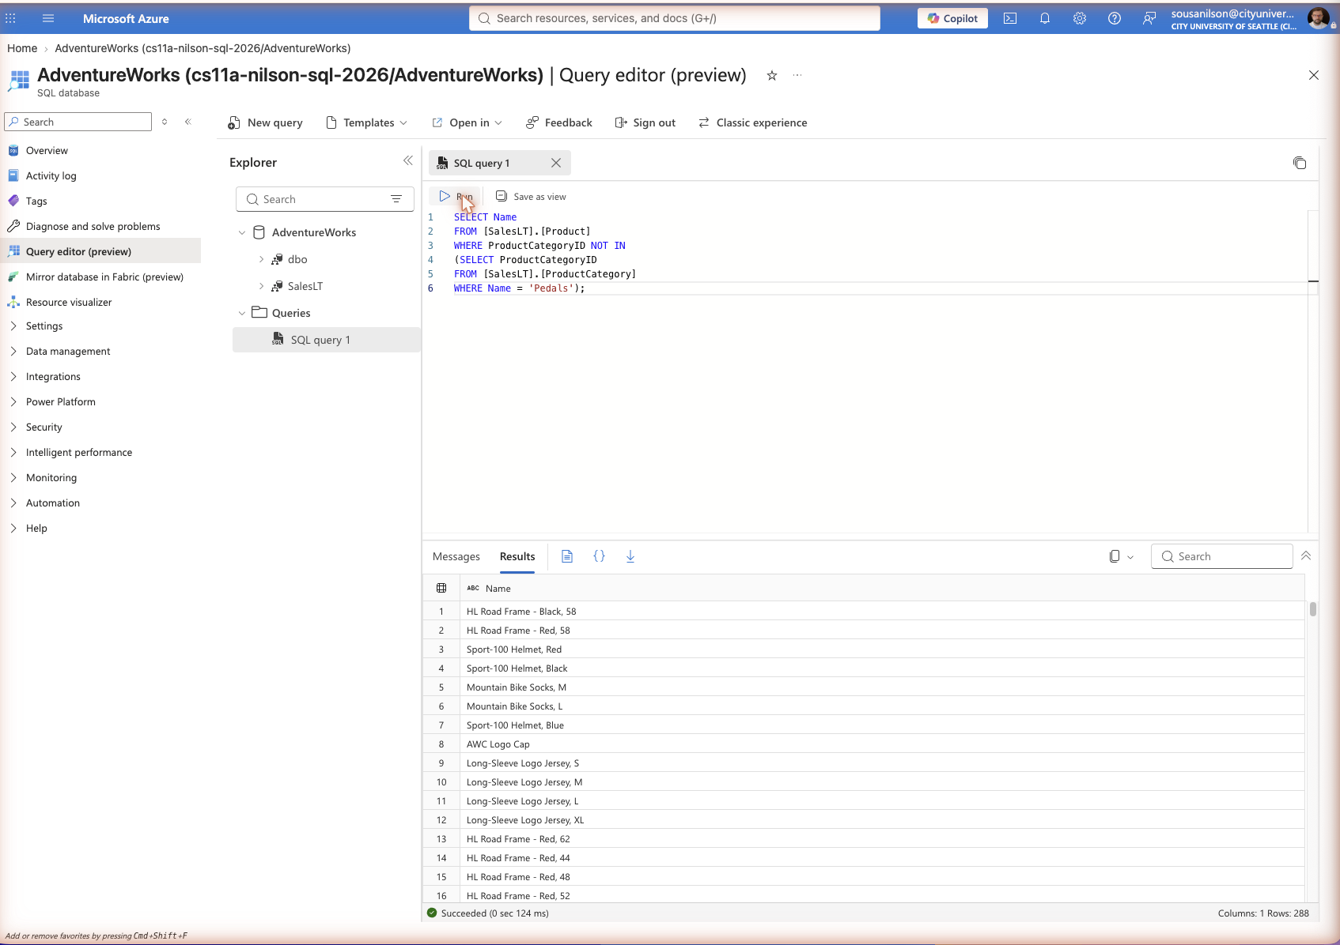

Technical: What is the command for? Why would you use the command?
This query returns every product that is NOT in the "Pedals" category, using a subquery inside a NOT IN clause. The column names here are implicitly qualified by the nearest FROM clause since no table prefix is given.
Application: What type of business user needs this information? Why does it need this information?
A merchandising team could use this to build a catalog view that excludes pedals, for example for a marketing email or storefront category that intentionally leaves out that accessory type.

2d. Qualifying column names in Subqueries with implicit assumptions
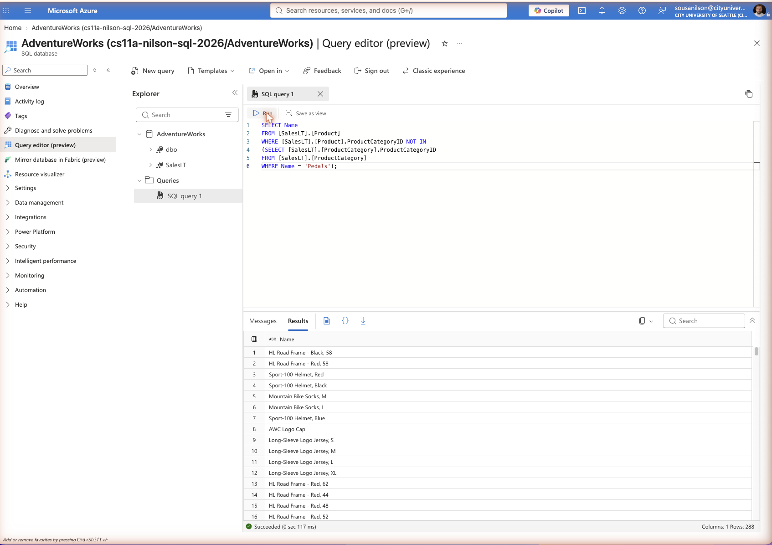

Technical: What is the command for? Why would you use the command?
This returns the identical result as 2c, but every column reference is fully qualified with its table name. This removes any ambiguity about which table a column belongs to, which matters more as queries grow to include multiple joins or tables that share column names.
Application: What type of business user needs this information? Why does it need this information?
Same business need as 2c. This style is useful for a developer maintaining shared or complex reporting queries, since explicit qualification prevents bugs if a column with the same name is later added to another table in the query.

2e. Correlated subqueries
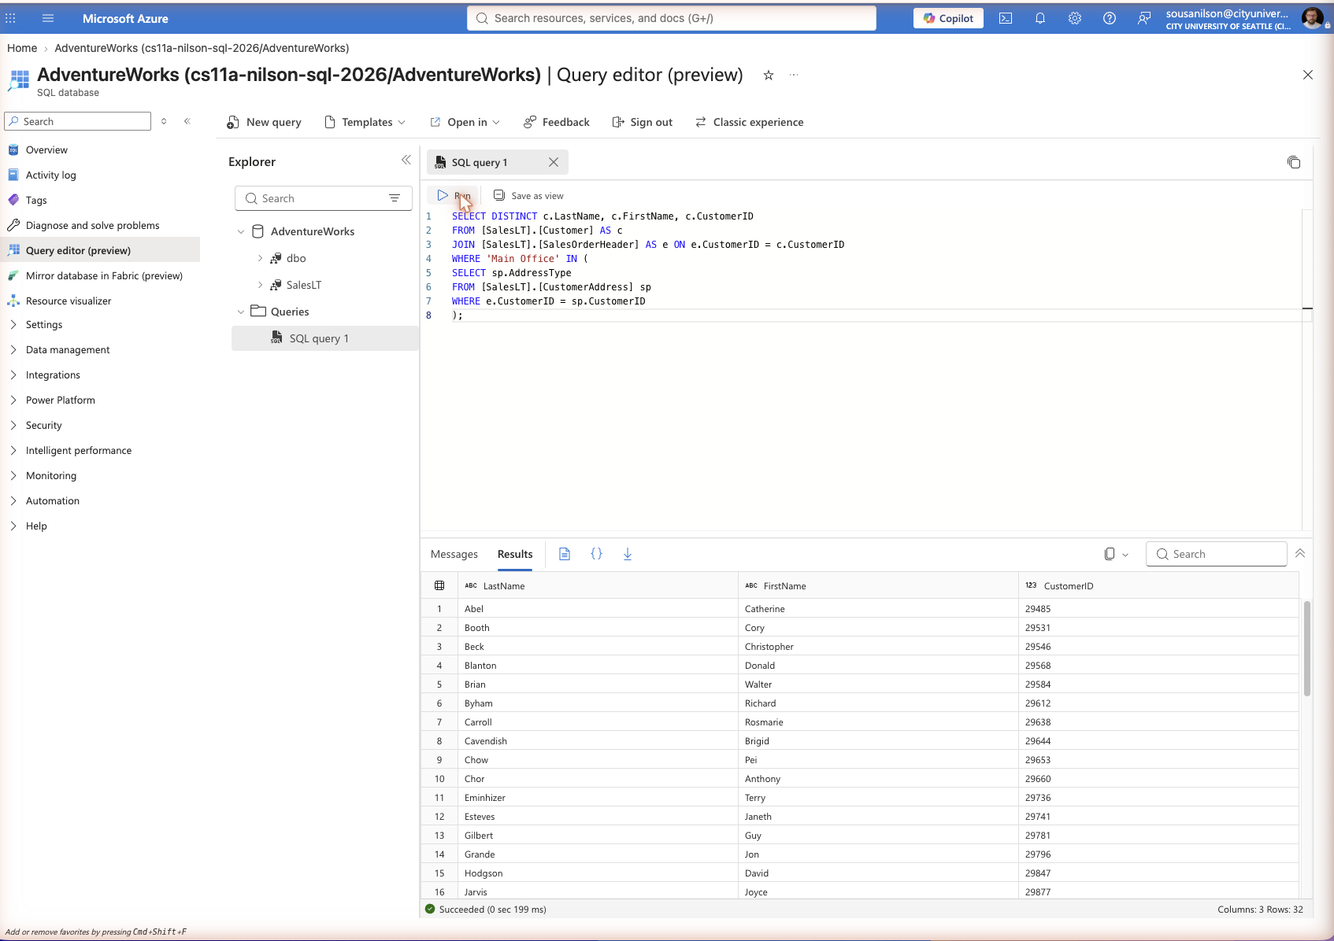

Technical: What is the command for? Why would you use the command?
A correlated subquery checks, for each customer joined to an order, whether that customer has a "Main Office" address type by referencing the outer query’s CustomerID inside the inner query. Unlike a regular subquery, this inner query re-runs once for every row the outer query considers.
Application: What type of business user needs this information? Why does it need this information?
A billing or account management team could use this to isolate customers who have a formally registered main office address tied to their orders, which is useful for B2B account verification and invoicing.

3a. Queries for inserting values in tables
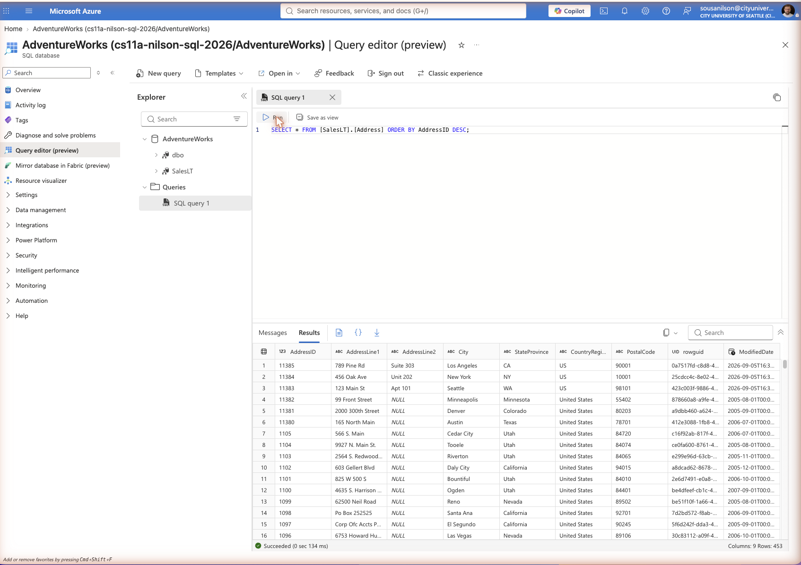

Technical: What is the command for? Why would you use the command?
The INSERT statement adds new rows to the Address table by supplying literal values for every non-identity column, in column order, using NEWID() and GETDATE() to auto-generate the unique row identifier and modified-date timestamp. It is used any time new records need to be added to a table.
Application: Can you add one new Address to the Address table?
Yes. As shown in the screenshot, three new rows were added (Seattle WA, New York NY, and Los Angeles CA), confirmed by the SELECT * query showing the new AddressIDs 11383, 11384, and 11385 at the top of the results, bringing the table from 450 to 453 total rows.

3b. Queries for updating rows in tables
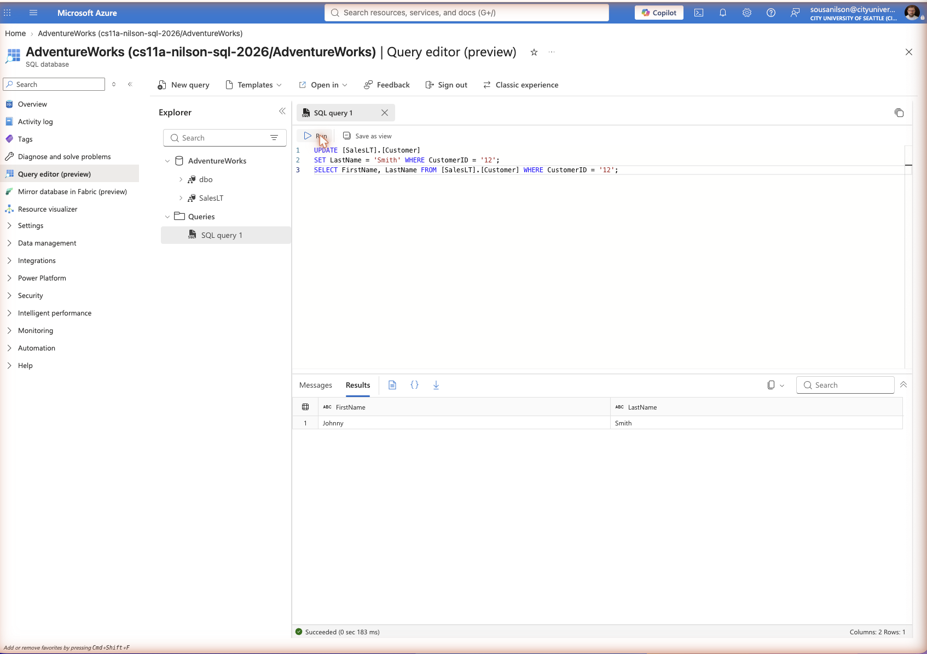

Technical: What is the command for? Why would you use the command?
The UPDATE statement modifies the LastName column for the single customer row matching CustomerID = 12, changing only that one column while every other field on that row stays untouched. It is used whenever an existing record needs to be corrected or changed rather than replaced.
Application: What is the new change in the Customer table? (Add screenshot)
CustomerID 12’s last name was changed to "Smith." The follow-up SELECT confirms the customer now shows as FirstName "Johnny", LastName "Smith".

3c. Queries for deleting rows from tables
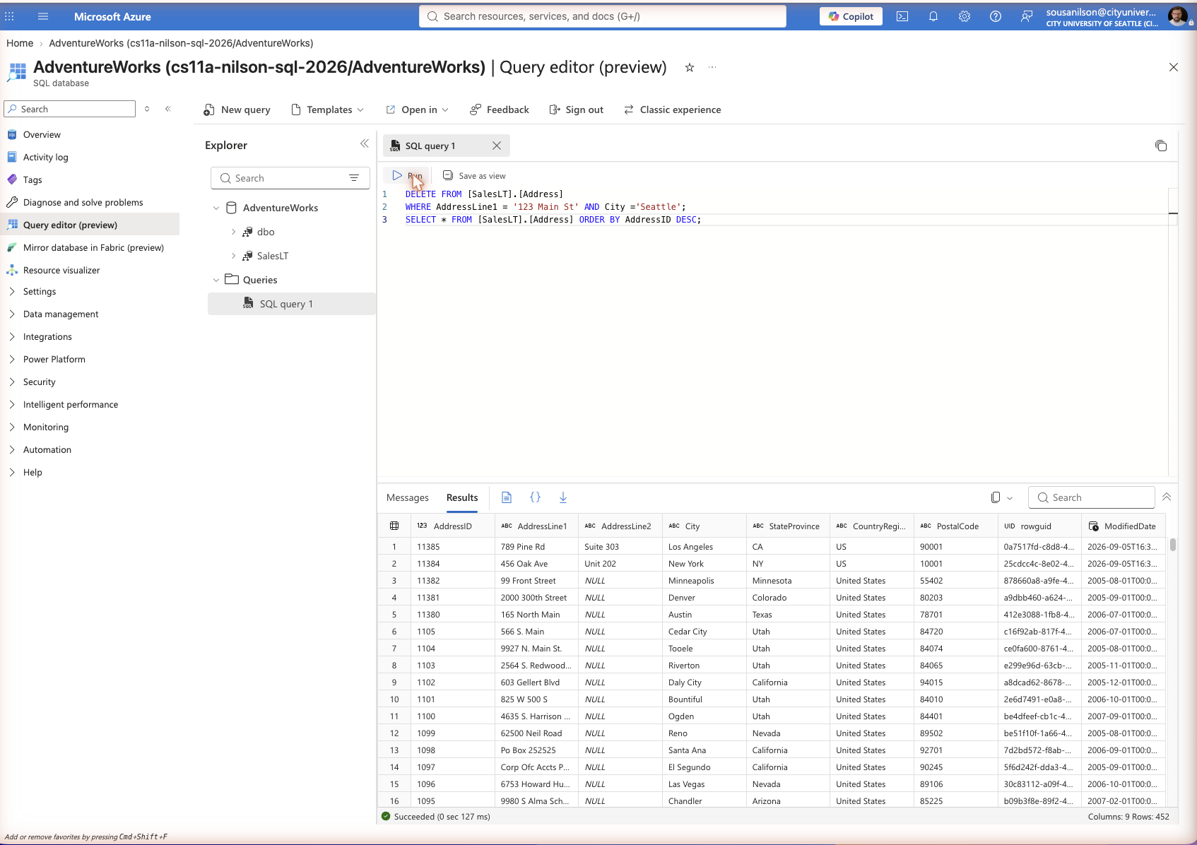

Technical: What is the difference between delete and truncate?
DELETE removes only the rows that match a WHERE condition (or every row if no WHERE is given), operates row by row, can be rolled back inside a transaction, and fires any row-level triggers on the table. TRUNCATE TABLE, by contrast, removes all rows at once by deallocating the data pages rather than logging each row deletion individually, cannot target specific rows with a WHERE clause, and generally does not fire row-level triggers. In this exercise, DELETE was used with a WHERE clause to remove only the "123 Main St" / Seattle address that had been inserted earlier, confirmed by the row count dropping from 453 to 452 and AddressID 11383 no longer appearing at the top of the results.

